DOEE is initiating a Citizen’s Engine Idling Enforcement Pilot Program to test the feasibility of expanding opportunities for District residents to assist in improving air quality. Under the program, citizens desiring to report violations of the engine idling regulations will use the District of Columbia 311 Mobile App (DC311 App) to report and submit information about violations in a manner that will allow for civil enforcement of the regulations. Prior to filing an engine idling violation report, please refer to these guidelines to ensure that the submission has the information necessary for a proper review and entry into the enforcement process.

The initial report of violation must be submitted through the DC311 App, https://ouc.dc.gov/page/dc311-mobile-app. Reports of engine idling violations under the Citizen’s Engine Idling Enforcement Pilot Program are limited to commercial trucks and buses. Trucks are any motor vehicles designed, used, or maintained primarily for the transportation of property, and includes vans that are primarily used to transport property. Buses are any motor vehicles having a seating capacity of twelve (12) or more passengers in addition to the driver and that are used for the transportation of persons. WMATA-operated buses and District of Columbia Government vehicles are not included for purposes of this pilot program.

20 DCMR § 900.1 prohibits the idling of gasoline or diesel-powered trucks or buses on public or private space for more than three (3) minutes while the truck or bus is parked, stopped, or standing, including for the purpose of operating air conditioning or heating equipment. When the temperature is at or below freezing (32 degrees F) trucks or buses may idle for up to five (5) minutes. However, trucks may operate their engines to power take-off equipment, such as dumping beds, cement mixers, refrigeration systems, winches, or shredders, and trucks.

Engine idling violation reports must include all of the information requested in the DC311 App, including your name, address, a telephone number, an e-mail address, and the location where the violation was observed. The report must include the state and plate number of the vehicle’s license. The DC311 App will allow for the submission of up to five (5) photographs, which must be stamped with the time and location and can be taken using the native camera within the DC311 App. Submitted photos must meet these minimum requirements:
- There must be at least 2 photographs to mark the start and stop of the observation period (when the time period is “for more than three minutes,” the observed time should be five (5) minutes or more; when the temperature is below 32 degrees F, the observed time should be six (6) minutes or more).
- There must be a photograph of the license plate of the truck or bus.
- There must be at least one photograph that shows any company identifying information or logo, and when on the vehicle, there should be a photograph of the U.S. Department of Transportation (DOT) number on the vehicle.

A Department of Transportation (DOT) number is a number the Federal Motor Carrier Safety Administration assigns to registered commercial vehicles. All carrier vehicles that weigh more than a certain amount, carry specific amounts of paying passengers or operate between state lines require DOT numbers. The DOT number will allow DOEE to more accurately and quickly identify the owner or operator of the vehicle. DOT numbers are usually on the side of the cab of commercial trucks, or on the front end of a bus near the front wheel well, as shown in the following illustrations:

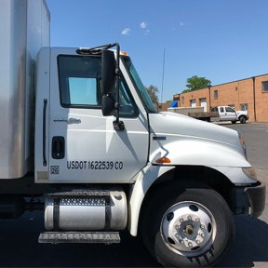

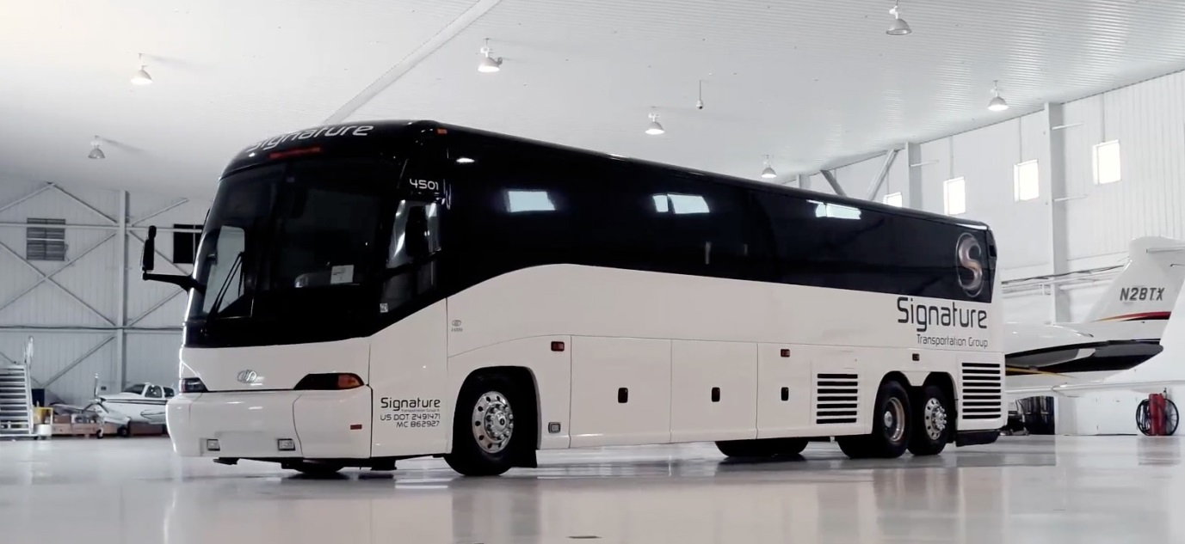

WHEN FILING A VIOLATION REPORT, DO NOT APPROACH OR VERBALLY ENGAGE THE DRIVER OF THE VEHICLE: The information required for the report does not require any information to be obtained from the vehicle operator. DO NOT ENTER PRIVATE PROPERTY TO OBSERVE A VIOLATION. All violations should be observed from publicly accessible areas.

Once the report of violation is received by DOEE through the DC311 App Portal, the report will be reviewed by a DOEE inspector who will determine whether the report has the required information. If so, DOEE will send the reporting person an affidavit to be filled out and signed with information regarding the violation, to be sworn under penalty of perjury. The inspector may also request from you any other information that may be necessary to process a violation case. When a case is filed, you may need to be available to testify in an administrative hearing.

